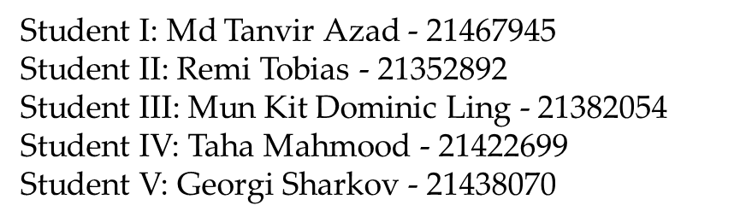

Group 16 Research Project: Task 2 Demonstration of the software & Project Report

group 16 | University of West London

Partsworld

E-commerce Web application

2021

Table of Content

Table of Figures and Tables 2

Introduction 3

Project Team 4

Literature Review (TM5) 5

Project Requirements (TM5) 6

Project Plan 8

1. Gantt Chart 8

2. Core risk Register to overall Project (TM5) 13

2.1 Personal Risk Register (TM5) 14

3. Website map 15

4. Unified Modelling Language Diagrams (TM5) 16

4.1 Activity Diagram 17

4.2 Use Case Diagram 18

4.3 Sequence Diagram 19

4.4 PERT Chart 20

4.5 Critical Path Analysis 21

Project Components and Documentation 23

Design Explanation and Justification (TM2) 23

Homepage Design 23

Responsiveness 23

Navigation & Links 24

Product Browsing & Sales Section 24

Brands section 24

Footer: Social & Contact Us 24

Database management System (TM2) 25

Entity Relation Diagram 25

Customer & Address 26

Product & Promotion 27

Basket & Wishlist 27

Customer Order 28

Payment 28

Cancelation & Refund 29

Supplier & Supplier Order 29

Included Functionality (TM3) 30

8.1.1- User Registration 31

8.1.2- User Login 32

8.1.3 Personal Page 33

8.1.4 Orders review 33

8.1.5 View of the Homepage and Products 34

8.1.6 Displaying Products 34

8.1.7 Products Filtering 35

8.1.8 Products Description 35

8.1.9 Cart Adding 36

8.1.10 Editing Basket 36

8.1.11 Checkout Process 37

Website Validation 37

Testing (TM4) 38

Analysis of the results 52

Group Activities 53

Group meetings 53

Collaboration 53

Personal reflection 56

Conclusion 56

References 58

# Table of Figures and Tables

Table 1: Risk Register 13

Table 2: Personal Risk Register 14

Figure 1: Website Navigation Map 16

Figure 2: Activity Diagram 17

Figure 3: Use Case Diagram 18

Figure 4: Sequence Diagram 19

Figure 5: PERT chart 20

Figure 6: Critical Path Analysis 22

Figure 7: ER Diagram 26

Figure 8: Command Line application in Python for basic Queries 30

Figure 9: User registration 31

Figure 10: Sign Up page 32

Figure 11: User Login Manager dashboard of the WIX template builder 32

Figure 12: Personal Page View 33

Figure 13: Ordering review of purchased products 33

Figure 14: Dashboard View 34

[Figure 15: Filtering Products 35](https://uwloffice365live-my.sharepoint.com/personal/21438070_student_uwl_ac_uk/Documents/Group%20Research-%20Group%2016.docx#_Toc71822623)

Figure 16: Example of Product Description 35

Figure 17: Adding Items to the Basket 36

Figure 18: Basket page view 36

Figure 19: UWL Group 16 File exchange platform 54

Figure 20: GitHub Group Project Repository for files exchange 54

Figure 21: Communication through Discord channel 55

Abbreviations:

UML- Unified Modelling Language

UWL- University of West London

WIX- Website company that provides web hosting

# Introduction

Our goal for this group work is to create a fully functional e-commerce platform with specific features for customers. The main goal is customer to be able to buy a product from the online store. The core features are comparison of the products, filtering by manufacturers and brands, add products they like seeing their full description and images. In addition, customer must be able to register an account before the purchase, edit items in the basket etc. (more details in the report). Our team as a group decided to create a website oriented on the computer parts selling. After consulting with all team members, we decided to go for the WIX website builder, as it was the platform that requires less technical skills for development. All personal and group tasks were uploaded to the GitHub repository as well as Group File Exchange from the Blackboard platform. For communication purposes and group meetings we used a Discord channel. Database was created in MySQL and uploaded to the repository. The Website is created following user requirement with some features added from the development team for better functionality.

# Project Team

We split all the tasks amongst us as project required involvement from all the team members. After team meeting every member. We realised that some members are not experienced in some of the fields, however we were happy to work together to do that challenging bit and get the skills and knowledge required for the tasks. To be more specific below is the list with our team members roles and tasks assigned:

**Team Member 1 –UI Designer, Team meetings.**

* Recording Group meetings
* Project Plan and Gantt chart
* User Interface design
* Website creation in WIX

**Team Member 2 - Developer of the Database and Testing**

* Analysis and gathering the requirements
* Database development and Entity Relationship Diagram
* Website sketch and Navigation Map
* Design Explanation and Description

**Team Member 3 – Web Developer and Web Designer**

* Web site features and functionalities
* User Interface design description
* Site Functionality
* Website Navigation Map

**Team Member 4 – Software Design and Development**

* Validation of the website pages
* Budgeting
* Testing
* Video Recording of the Website

**Team Member 5 – Team Leader and Developer of the UML diagrams and Quality Assurance**

* Documentation: Use Case, Sequence, Activity diagrams, Pert Chart, Critical Path.
* Methodologies and literature review
* Report structuring and content creation
* Creation of the Platform Channels (GitHub, Discord)
* Content control

# Literature Review (TM5)

Use of methodologies in software creation process is increasing continuously. Every methodology has the best use in the development stage. However, developing software has its own best-known methods and it is important to determine the best used ones in the past. Our team decided to use Agile methodologies in the software development. We were based on the team-work approach and involvement of each member in the creation of the website. Self-organisation and team cross-functionality is leading to the high-quality product. Agile Manifesto (main principles behind) was created by seventeen software industry members in 2001 Utah, Snowbird Ski Resort, USA- based on their experience and approaches that worked best for the goal (Cunningham, 2001).

Over the last decade organisations used such agile methods as SCRUM, RAD (Rapid Application Development), XP (Extreme Programming), DSDM (Dynamic System Development Model). These methodologies are approved and advantageous in the development process. They can be easily adapted to the company’s software needs. Agile methodologies (we will focus on the SCRUM here) have many benefits to the Customer such as higher speed of development process and quicker delivery of the high-value features by short cycles over the “waterfall” models. Benefit to vendors is visible by increasing the efficiency and improving the customer satisfaction and getting more positive references. The wastage is reduced by focusing on high-value features that allows to reduce the time-to-market and increases efficiency which in waterfall model is overhead. Development teams enjoy the benefits from the agile methodologies by reducing the non-productive work like writing the specification (that are taking too much time) which is this way gives more time to the team to focus on the work itself. This allows to maximise the value of their work and value to the customers. According to the product managers and project managers the benefits of using the agile methods are in re-prioritizing the work and maximising the delivery value according to the customer needs. Planning and tracking of the job are much easier and more concrete than in waterfall model process. Daily SCRUM meetings give managers possibility to track the project state and always display the progress. This will help tracking and resolving issues quicker. Stakeholders also receive benefits by showing them the project development sate, which allows them to plan the strategies more effectively (CPRIME, 2021) (Smith, 2007)

However, every good comes with a bad. The most important is that it is less predictable in time of efforts and product life cycle. New teams for the agile methods can be frustrated and be afraid of unknown methodology, when waterfall model process is well known and makes the process more regimented with time, cost, and final delivery of the product. With continuous interaction between the customers, developers, and testers such as face-to-face meetings, close cooperation, signing -off each phase and marking the development phases the process of development become onerous and time-consuming. User needs to be more involved in the process and to collaborate with the development team as well as training team. Software quality will reflect any lack of the participation from the client side. Alongside with previous drawbacks, lack of detailed documentations during development process leads to misunderstandings for the new staff members joined the current team. This method requires for start nothing but little planning with customer’s needs. This can lead to focusing on the wrong requirements and potential wrong development areas. This can extend the potential product release (FRIDMAN, 2016).

Our group-16 decided to use the agile methodology- SCRUM. We were meeting every week to outline and decide the working plan, next tasks and tasks that were completed. We established a Discord server for that purpose as everybody had the easy access for that platform. One member of our team was organising the meetings and was controlling the other members in their task’s completion. At the same time when somebody was having issues with the task it was easier to ask for the help from the other members. We were having a SCRUM leader using this methodology. This worked fine for us. We were able to assign the tasks and develop the webstore together.

# Project Requirements (TM5)

Following the case study our team set up next requirements for the website application. “Partsworld” team aimed to create a fully operational computer technology sales platform. Team was focused on requirements that will increase the potential outcomes for the customers. User requirements from the presentation part were taken as a core website features. Some new features were offered to be included from different team members regarding their components. Team decided to monitor the subscriptions and add some blog lines if there will be a relevant time left for that. Below are the requirements that should be applied in the development process of the website:

1. Home Page:

* Sign in or Registration
* Display of the Popular items
* Products reviews
* Banner with Sales and Discounts
* Social links and contacts

1. Login and Registration page

* User creation
* User Login
* User Details

1. Shopping Page

* Description of the Items
* Add to cart and quantity control
* Products Filtering (manufacturer, brand, price, name)
* Modify shopping cart

1. Basket (shopping cart) page

* Remove or add a product
* Quantity modification
* Checkout link
* View details of the product
* Add discount code

1. Checkout page (payment)

* Payment details
* Shipping details
* View details of the order
* Pay the order
* Place the order
* Cancel the order

1. Admin page

* New user
* Change Details
* Modify orders
* Update the store orders
* Report creation
* Manage the stock
* See the hot sales

There are more components that could be included in the webpages, however the team tried to stick with the main requirements to be able to meet the time plan. As suggested from our team members we decided to add some features as:

* Blog section
* Social Networks links
* Reviews of the products
* Company history and feature plans.

# Project Plan

## Gantt Chart

For creation of the Gantt chart, we used Microsoft Project. It shows the tasks and time that requires for implementation. These tasks in the development process could be adjusted accordingly to the case study.

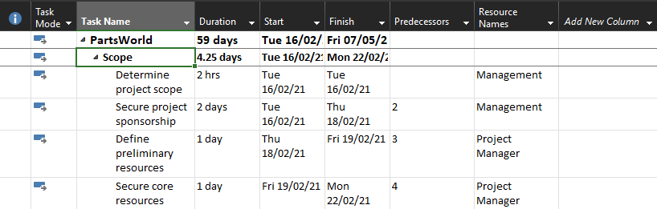

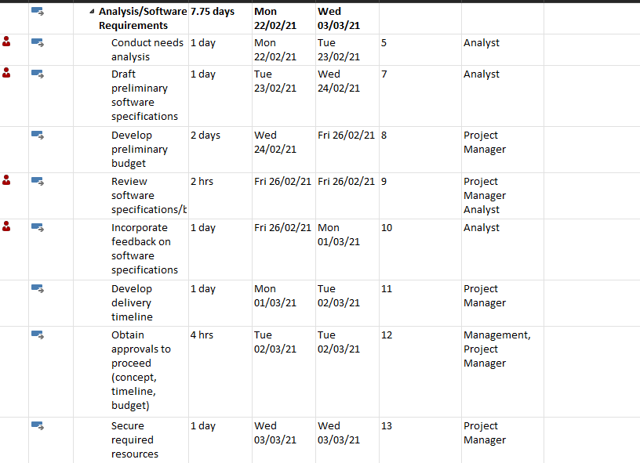

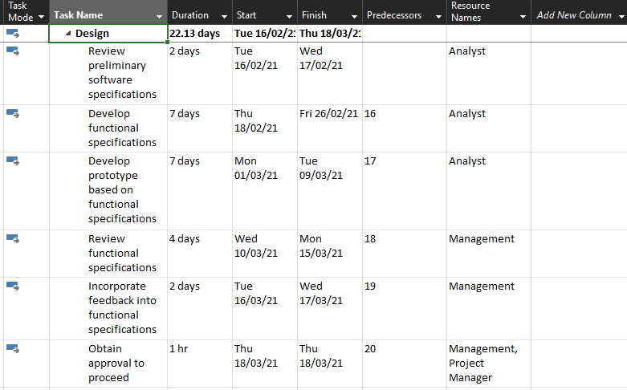

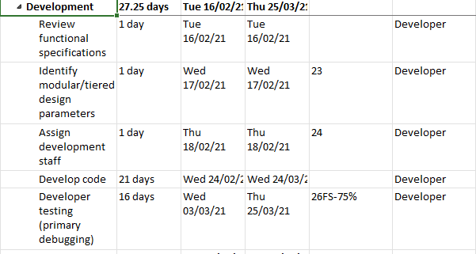

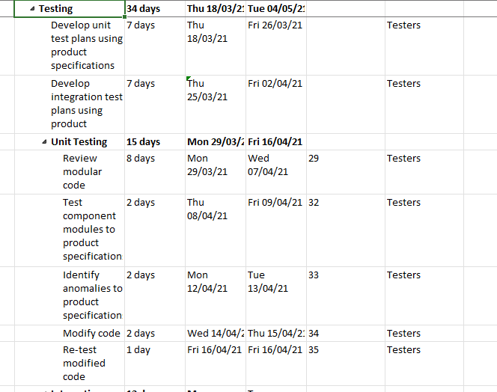

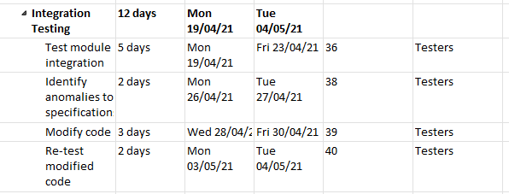

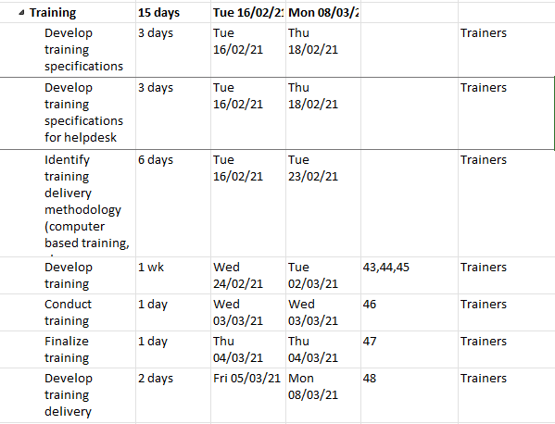

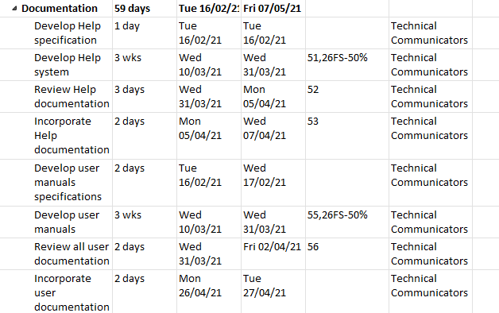

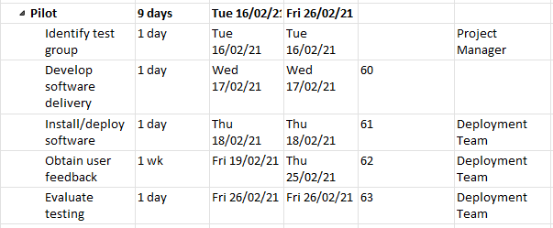

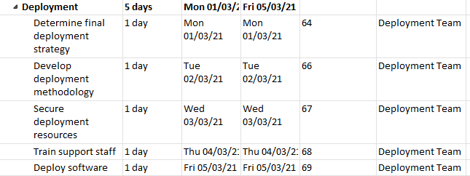

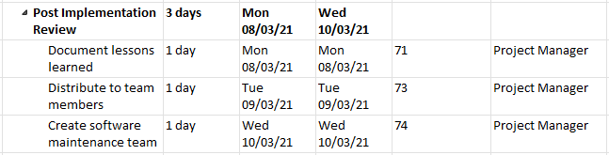

## Core risk Register to overall Project (TM5)

It is very important to identify the main risks to the project. We have a table that shows all possible risks we may have during the development process. Risk management process requires to identify all negative and positive impact on the team and the project progress. If we look at our team and try to identify the negative impact first thing that comes in mind that we cannot finish the project before the deadline time. Biggest risk is related to the low participation of the team members and possibility to miss the deadline. In the table below we will try to include all the risks that we faced during our project:

|  |  |  |  |  |  |  |  |
| --- | --- | --- | --- | --- | --- | --- | --- |
| **№** | **Type of Risk** | **Overview** | **To whom is related.** | **What can we do?** | **How serious is the Risk?** | **Difficulty** | **Status of the risk** |
| **1** | Finishing tasks on time | Some tasks have difficulties (testing, website building) | Management team | More competent members to help less competent in completion. | High risk | Complicated | Still Open |
| **2** | Paid features included on the website to meet the requirements. | Some components are paid only. | Budgeting team | We tried to overtake that with free resources available. | Low impact | Not so complicated | Closed |
| **3** | Developing the webpages | WIX platform requires more training and some features as payment method checks are more complicate. | Development team | Additional research and video tutorials | High impact | Not so Complicated | Open |
| **4** | Level of team members participation | Less participation from some members | Management of the Project | Better communication and more help from each-other | High Impact | Medium | Open |

Table 1: Risk Register

Every team member needs his own risk register to complete his tasks on time, based on the role. Below is my Individual risk register:

### Personal Risk Register (TM5)

|  |  |  |  |  |  |  |  |
| --- | --- | --- | --- | --- | --- | --- | --- |
| **No** | **Type of Risk** | **Overview** | **To whom is related.** | **What can we do?** | **How serious is the Risk?** | **Difficulty** | **Status of the risk** |
| 1. | On time with the tasks | Some tasks got me struggle and needed more time (UML diagrams) | Personal (Management of the Project) | More research about each of the Diagram | Highly rated | Difficult | Closed |
| 2. | Not enough knowledge in Project Planning | Not having enough competence in assigning tasks and gathering the required data | Personal, Management of the Project | Read additional literature (Teamwork and Project Management by Karl A. Smith) | Medium Risk | Not Difficult | Closed |
| 3. | Time-management | Some tasks could be delayed | Management of the Project, Personal | Better quality of the work over the quantity | Highly risky | Difficult | Closed |
| 4. | Too many personal tasks | Taking many personal tasks for completion causes stress of not completing all of them | Personal and to whole group | Try to assign to each member of the team some tasks. Leave some additional personal activities after submission. | Very High risk | Difficult | Closed. |

Table 2: Personal Risk Register

As it is shown above my personal risk register shows that biggest risk is taking too many personal tasks and that can cause frustration of not doing them on time. This can be followed by not having enough time to complete all of them.

## Website map

In the diagram below it is our website skeleton. It describes the home page structure and all the components included with subpages. This map helps to understand the website structure and describes the possible product access. Looking at this map user can make his/her way to the required page.

**Home page** includes Sales, Best Sellers, Login, Deals, Help, Contact, Shopping cart, Products subpages.

**Sales page** will show all possible items that are on sale now which user can easily add to the shopping card from there.

**Best seller** page will show the products that are in high selling demand now and can add the item to the basket.

**Login** link can log the user in. User will be redirected to the administrator page or to the main home page depend on the privileges given.

In the **Help** section user can seek advice or help using the search form or following the FAQ.

In case of any further request regarding the order user can find the contact details on the **Contact Us** page or using contact form.

At any time, user will be able to access the **shopping cart** page, where he/she can review, edit the items, or proceed to the checkout.

**Product Page** is one the most important pages. Here user can navigate through different categories of the items, such as Computer and Tablets, Drones and Cameras, Speakers and headphones, Mobile phones, TV and home cinemas, wearable technology. From any of those pages it will be possible to view the item description and add it to the shopping cart.

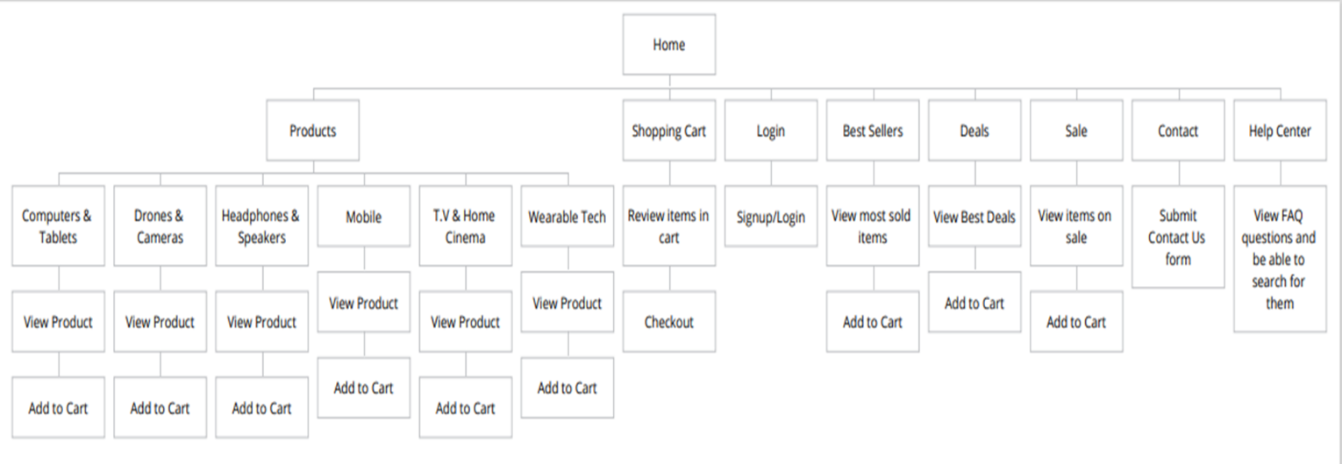

Figure 1: Website Navigation Map

## Unified Modelling Language Diagrams (TM5)

The purpose of using modelling diagrams is to show the customer or developer teams the actual behaviour of the system and to help in understanding how website should be structured based on user requirements. For all diagrams below we have used free online platform- “online.visual-paradigm.com”. This gives clear understanding what functionalities to include and reflects the requirements.

### 4.1 Activity Diagram

This diagram will give better understanding to the users (admins) accessing the web platform and will highlight what are the possibilities for each user in the system. As it is shown below user can register, login with existing credentials or simple browse the website as a guest. It is possible to navigate through the pages, see, search, add items, edit the basket. Card payments by completing the purchase and checkout options are also available. In addition, the diagram has notations and diagram map on the top. By following the notations, it is easy to understand the initial and final phases, along with the users’ specific possibilities. Administrator can add, edit, remove, update the items. All users’ credentials will be checked before accessing the main page.

Figure 2: Activity Diagram

### 4.2 Use Case Diagram

This diagram below will help us to show graphically user’s interaction with the software. Different type of users is displayed and their interaction at different stages. In the diagram eclipses are representing the use cases. In this case we have two main type of users: “User” and “Admin”. User can be “New”- in this case he/she will be offered to register an account or browse as a “Guest”. There will be a registration checking mechanism, which will show if the user entered right credentials with related popup message. After browsing through the pages user will be able to check out the items going through several interactions with the customer authentication, card processing systems. At the same time after user’s item selection system will check the availability of the items. Before paying the item, payment system will check for available funds at the user’s card. Administrator will have additional privileges as: “Adding items and categories”, “Managing Items, Orders, Prices”.

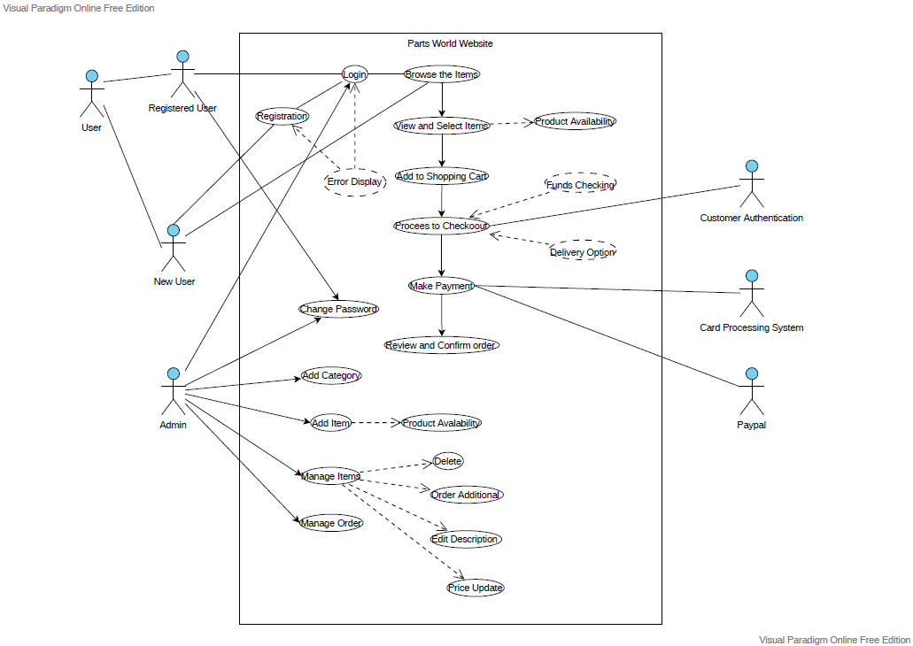

Figure 3: Use Case Diagram

### 4.3 Sequence Diagram

This diagram below will help to show the interaction between different objects in different time sequence. It will show the functionality at different scenarios needed for message exchange. Administrator and User exchange different information between webpage they are browsing and database on the servers. The dataflow is graphically represented in the diagram by showing connected arrows to the different systems. This will help in clarifying the work of different systems in the process of execution a task. To be able to function properly the system needs to work in a sequence with different parts. From the diagram we can see how users are going through login authorisation process, where system is checking their account information. After authorisation, user starts interaction process with webpage and webpage refers the request to the server. After communication establishment server refers to the database for response. In case when database has the required item, the request is sent to the purchase interface and after to the card payment system. Interactions in the diagram are represented as lines and replay information as dotted lines. Processes performed are represented as opaque rectangles in response to a request. Some comment boxes are added for clarification.

Figure 4: Sequence Diagram

### 4.4 PERT Chart

PERT (Program Evaluation Review Technique) chart purpose is graphically to show main elements of the project with all development stages within assigned timeline. All tasks are dependent on each other. Element 2 path will give us the most advanced program to finish the project, which we are in now. All Elements are showing the paths to complete their tasks.

Figure 5: PERT chart

### 4.5 Critical Path Analysis

Critical Path Analysis includes more detailed tasks used in the project. It is based on the tasks that are core to the successful completion. In the table there are tasks listed with the dependant subtasks. Every task has assigned dates and description along with predecessor activities. Circles below represents tasks and with letters inside on the top side as a task number and bottom number as days to complete that activities. Arrows represents connections – path to choose to finish the task.

Figure 6: Critical Path Analysis

# Project Components and Documentation

In this part of the report will be explained how the website was created with some further details. We decided to create the online platform using WIX, which now is fully functional and secure. Each page is supported with screenshots and explanations.

## Design Explanation and Justification (TM2)

### Homepage Design

The homepage is the first page that the customer will see when they visit “Parts World”. The page has a clean design where customers can view products and deals on the front page, enticing them to sign up. A brief description of what Parts World is about can be seen on the homepage to give visitors an idea of who and what “Parts World” does. On the front-page customers and visitors can also see the trusted brands that work with “Parts World” to give confidence in signing up to the website.

### Responsiveness

The website can be view on both mobile a tablet device for customers to comfortably browse the website on the go without being at a desktop. Text and navigation links are designed and scaled for customers to enjoy browsing and purchasing item on the go.

### Navigation & Links

For desktop sites we used a simple list navigation with the links displayed in a row with the login/profile icon and basket icon position to the right. To tell the customer what page they are currently on, the navigation bar item is a different colour to the other navigation items. (the current page is dark blue, and the others are white.)

On the mobile layout, the navigation bar collapses into a column that can be view with the navigation bar icon (The one with the three lines) and hidden by pressing the X icon. The links have the same functionality to tell the customer which page they are on based on the colour of the links.

### Product Browsing & Sales Section

On the products page, the image of the products that are sold can be viewed clearly on the desktop. The only information that can be seen is the name of the product, the price and weather the item is new or on sale. To view more information on one the products the customer would have to click on one of the images. It is also possible for a customer to filter buy parameters, such new, colour or size. The sales section is like the products section, however, only lists items that are on sale.

On the mobile version of the site the customer can scroll to view products. To filter out products with parameters can be change at the top of the website.

### Brands section

When customers visit the “Parts World” website, they can view the different brands “Parts World” is partnered with when it comes to selling products. Working with trusted brands help earning customers trust when it comes to buying products.

### Footer: Social & Contact Us

Customers can get information about “Parts World” from the footer section of the website. Information such as store location and opening times can be found in this section if a customer needs to come to the store for a personal enquiry. To inform customers of how to handle issues without coming into the store, we have a list of personal policies for each case we were able to think of. Any other cases can be found on the FAQ’s page.

Customers and users just visiting the website can view the popularity of “Parts World” on other social media sites by clicking on the icons in the footer. For customers that choose to follow “Parts World” on social media, will be the first to get updated on deals and premium products that will be displayed on the website.

## Database management System (TM2)

For this part of the report, I will go into detail about the database fits into the project. The database plays a crucial part within the project as it is responsible for holding the information about the customers such as addresses, payment information and order information. The database also contains information about the products such as brand, pricing and a description about the product.

### Entity Relation Diagram

The image below is the entity relationship diagram, which illustrates the entities that will be used within the database and the relationship they have with other entities. Each entity has attributes which shows what data they hold and the type.

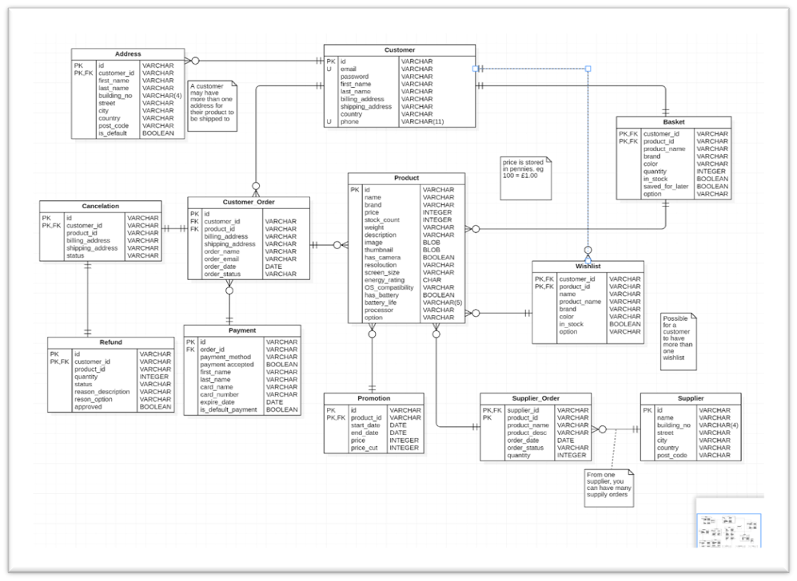

Figure 7: ER Diagram

### Customer & Address

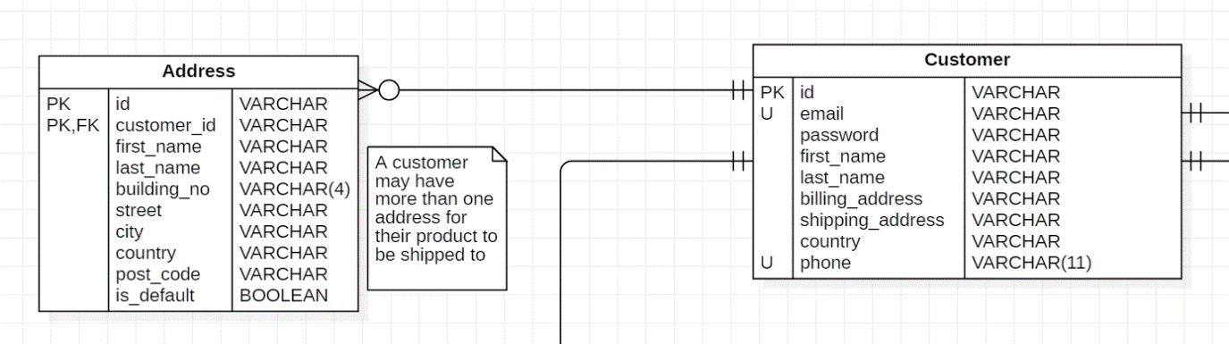As soon as a customer signs up to website the Customer and Address table get populated with data, each customer is given a unique id which is in both the Customer and Address tables. This id is a primary key in the Customer table. The address table has its own id and a composite primary key using the id and the customer_id, because it is possible that one customer may have more than one address, or two customers may live at the same address. To know which address to deliver to, the Address table has an is_default attribute to tell which address an order should be delivered to.

### Product & Promotion

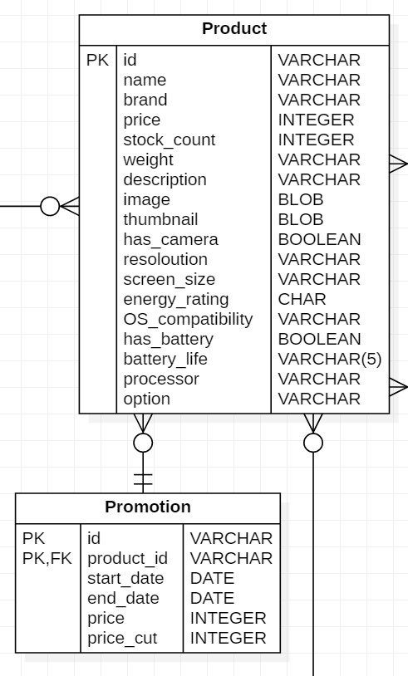The Product table contains all the information on products that are received from the supplier and contains the most attributes. Not all the attributes will contain data because it is very unlikely that a product will meet all the parameters (e.g., a processor does not have a battery life). All products will be uniquely identified with the id attribute which is also the primary key. Weather the product is in stock and the amount of stock will be shown on the website. If a product is not in stock, then an estimated delivery date will be shown on the website.

For products that have a promotion applied to them are a part of the Promotion table. A composite primary key is made using the id and the product_id attributes. All promotions have a start_date and an end_date for the beginning and end of a promotion. This makes it easier it applies a promotion if a promotion is seasonal. The price in the Promotion table is determined by the price in the Product table and the price_cut in the Promotion table.

### Basket & Wishlist

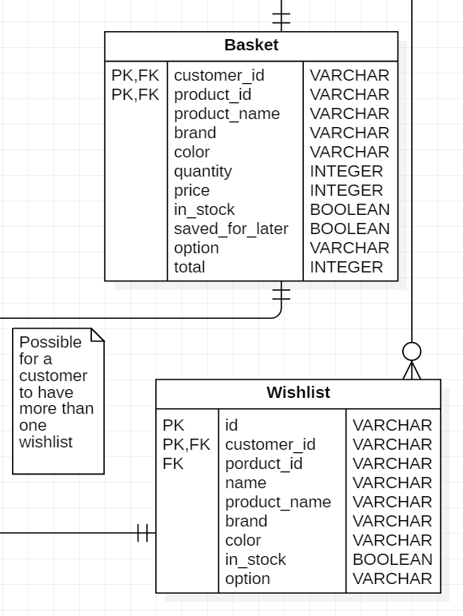Each customer can have one basket in the same way a customer enters a supermarket and picks up a basket or a trolly to do their shopping. The Basket table has a composite primary key composed of customer_id and product_id. The saved_for_later attribute is for items that are not added to the total order if the customer decided they wanted to purchase an item later and not look for it on the website again.

It is possible to a customer to have more than one wish list. The Wishlist table has a composite primary key made from the id and the customer_id attributes. Each wish list can be named by the customer if they chose to. Products that are in the wish list can have a description and a quantity to let other customers that use the website know how much to buy.

### Customer Order

Because each customer can have multiple orders, it makes sense for the Customer_Order table to have an id attribute, this id attributes acts as a unique identifier to easily identify a customer’s order. For the Customer_Order table to get information about the customer and the product, the Customer_Order table has the attributes customer_id and product_id which act as foreign keys that relate to the Customer table and the Product table.

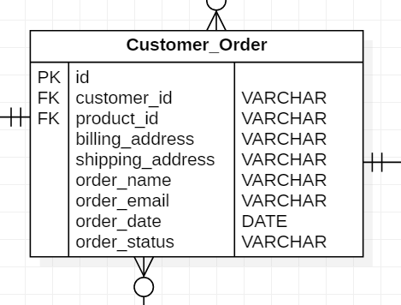

### Payment

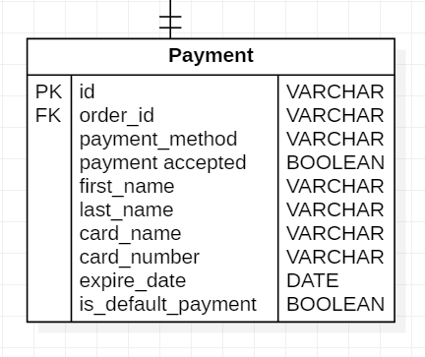Customers can have multiple payment methods for an order, however only one payment method will be used for each customer’s order. Payment can be differentiated by the id attribute and information about the customer can be accessed via the order_id attribute which is a foreign key. When a customer is about to pay for an item, they can choose which way they would like to pay for their order. The customer can also set a default payment method if they want to speed up the payment process. If the desired payment method has passed the expire_date attribute the payment is rejected.

### Cancelation & Refund

If a customer happens to change their mind about an order, they can choose to cancel the order before the product is delivered. The Cancelation table has a composite primary key using the id and customer_id attributes. Using the customer_id attribute as a foreign key helps access the customer information in the Cancelation Table. If an order happens to be delivered before the customer can cancel, then the customer can choose to return the item to the warehouse. Like the Cancelation table the Refund table has a composite primary key made using the id and customer_id attributes. When the product that is returned to the warehouse, they database will the approved attribute to let the system know the refund is approved.

### Supplier & Supplier Order

The products that get delivered to the warehouse come from the supplier. Each supplier can send out many orders, these orders are stored the Supply_Order table, which is the table that contains the products that get sent over. If there is ever a problem with an order, the supplier’s information can be accessed from the Supplier table.

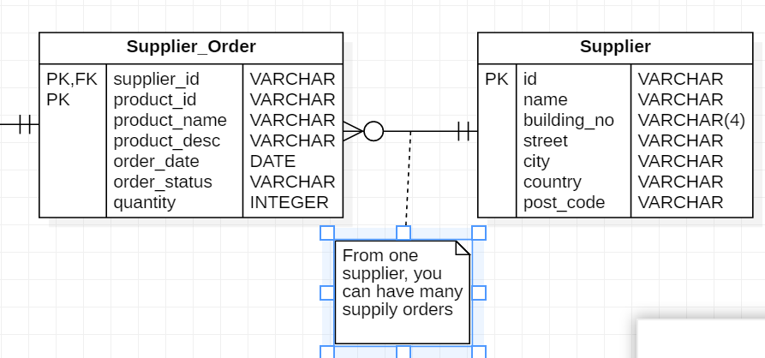

For the database management system, I created a simple command line application in python for performing basic queries. When a customer phones the customer service line about a problem with their account, customer services can solve the problem without having full access to SQL queries, any serious problems can be passed to an administrator to be solved.

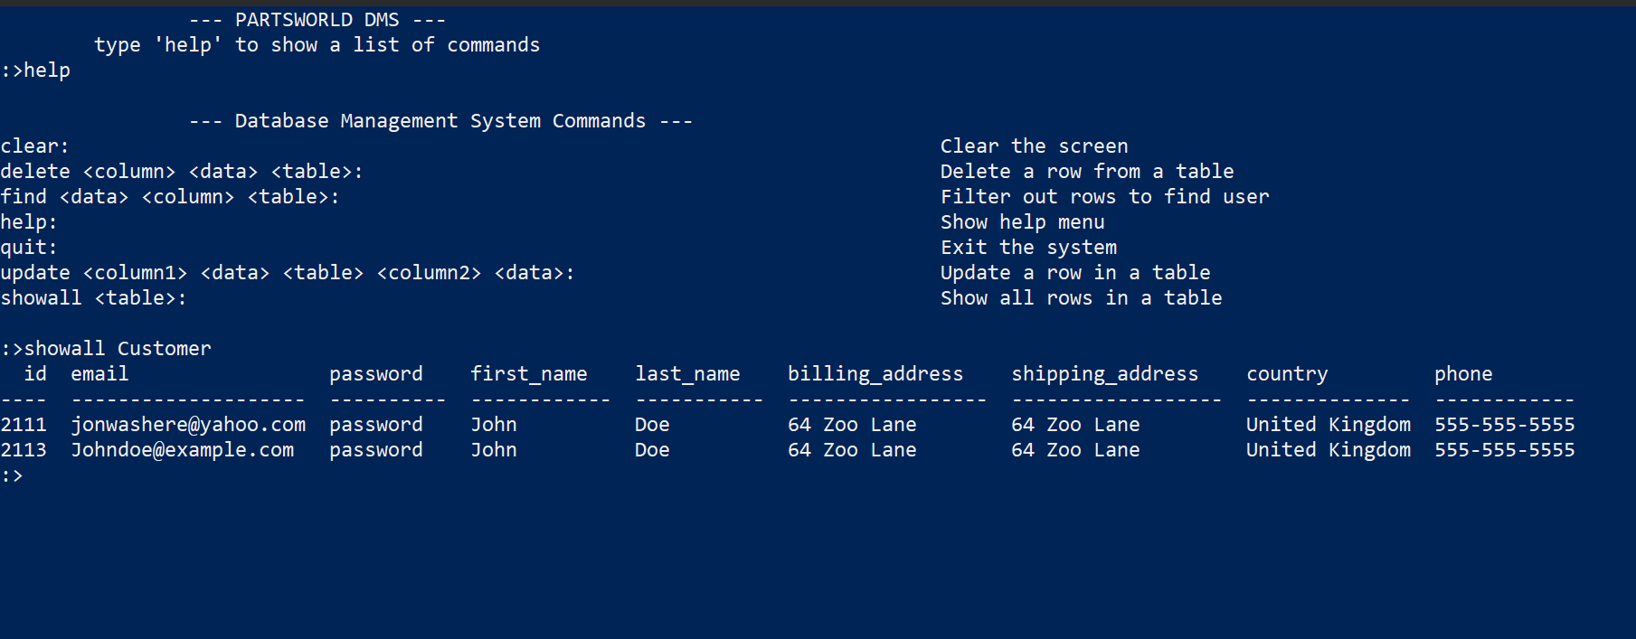

Figure 8: Command Line application in Python for basic Queries

## Included Functionality (TM3)

This project was created using WIX web platform, as most of the group members agreed on. We named the website: “Partsworld” as we were planning to sell electronic devices and computer parts. As our group consists of members from different cohorts (Cyber Security, Computer Science) some team-members would have a hard time to complete the tasks in other CSS platforms or HTML. This worked fine for us as we were able to create a nice-looking fully functional website. Testing showed that customers liked the structure and design of the website and shopping process is easy and intuitive. Many features included on the website allow users to browse through the pages content and see the details they need. Below is the list of the functionalities that were accomplished:

### 8.1.1- User Registration

User registration is handled primarily on the WIX Template builder back-end. Due to the ease of development, scripting functionality with source code has been avoided which, as an advantage is less costly to development, but adversely sacrifices flexibility of design with regards to the website.

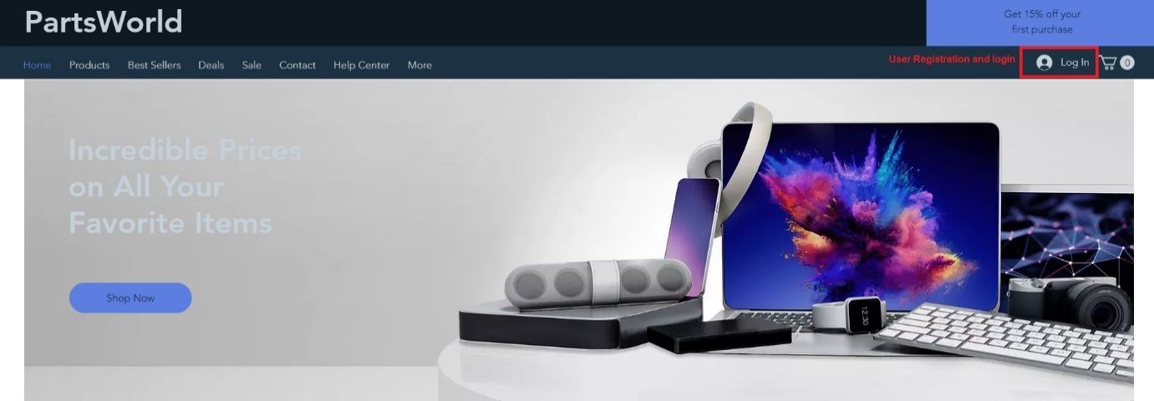

Figure 9: User registration

You will need to firstly click “Log In” at the very top section of the website. You will then be presented with a login page where you can use credentials if you have already signed up to the site, however, in this case, we will create an account instead by clicking to “Sign up” using either Facebook, Google or email address. Which then sends us to a registration page.

Figure 10: Sign Up page

As we are using WIX to sign up it only has an email section where a user can register an email and a password section.

### 8.1.2- User Login

User Login is handled by the WIX Member Login/User Registration form. This functionality is abstracted from the developer and interfaced through a GUI. This approach is time-efficient and so it is what is being adopted for this project.

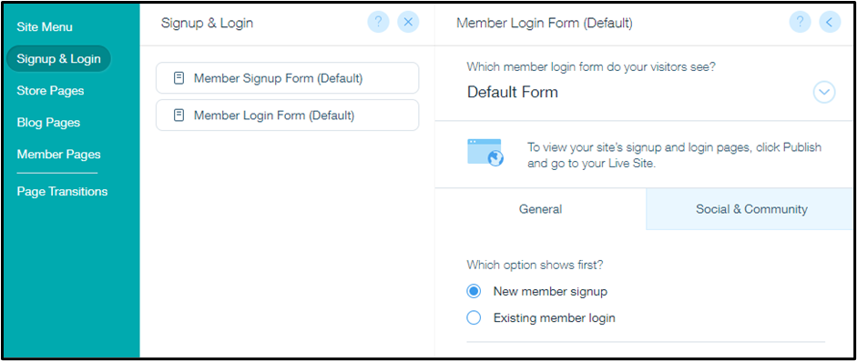

Figure 11: User Login Manager dashboard of the WIX template builder

### 8.1.3 Personal Page

The personal page consists of a profile, order history, address lists, wallet, and account information. It allows the user to customize their experience using the website as well as keep track of their transactions.

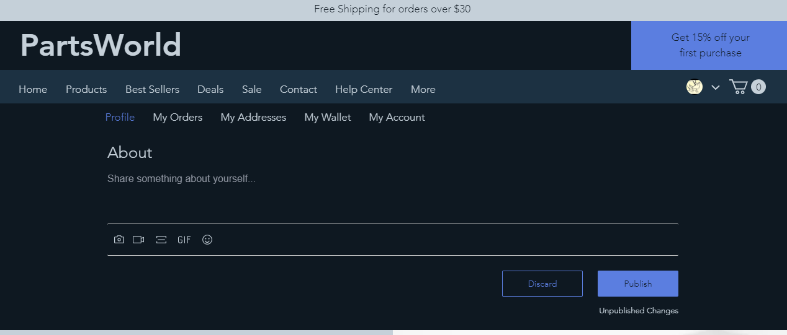

Figure 12: Personal Page View

### 8.1.4 Orders review

The orders review allows the user to see a summary of all the previous orders made from the website. It is accessible via the Personal Page.

Figure 13: Ordering review of purchased products

### 8.1.5 View of the Homepage and Products

The view for the home page features a variety of sample images representing the stock.

Utilizing a panel layout keeps the images organized and easy to view. The home page is scrollable with featured products and deals. The layout is handled via a block-style editor on the WIX Template Editor.

The dashboard is a convenient way to keep track of the page files without having to learn source code. The output is organized, and the back end is manageable.

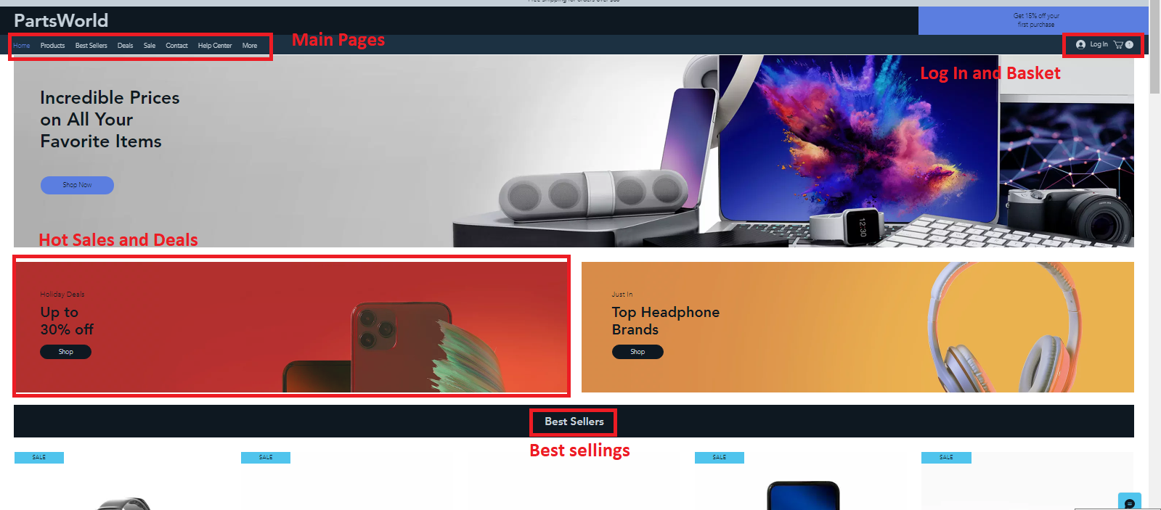

Figure 14: Dashboard View

The dashboard is a convenient way to keep track of the page files without having to learn source code. The output is organised, and the back end is manageable.

### 8.1.6 Displaying Products

Through a panel system provided by the WIX template builder, product images are placed onto the pages with respective text. The UI is clear yet customizable from the back end via the designer.

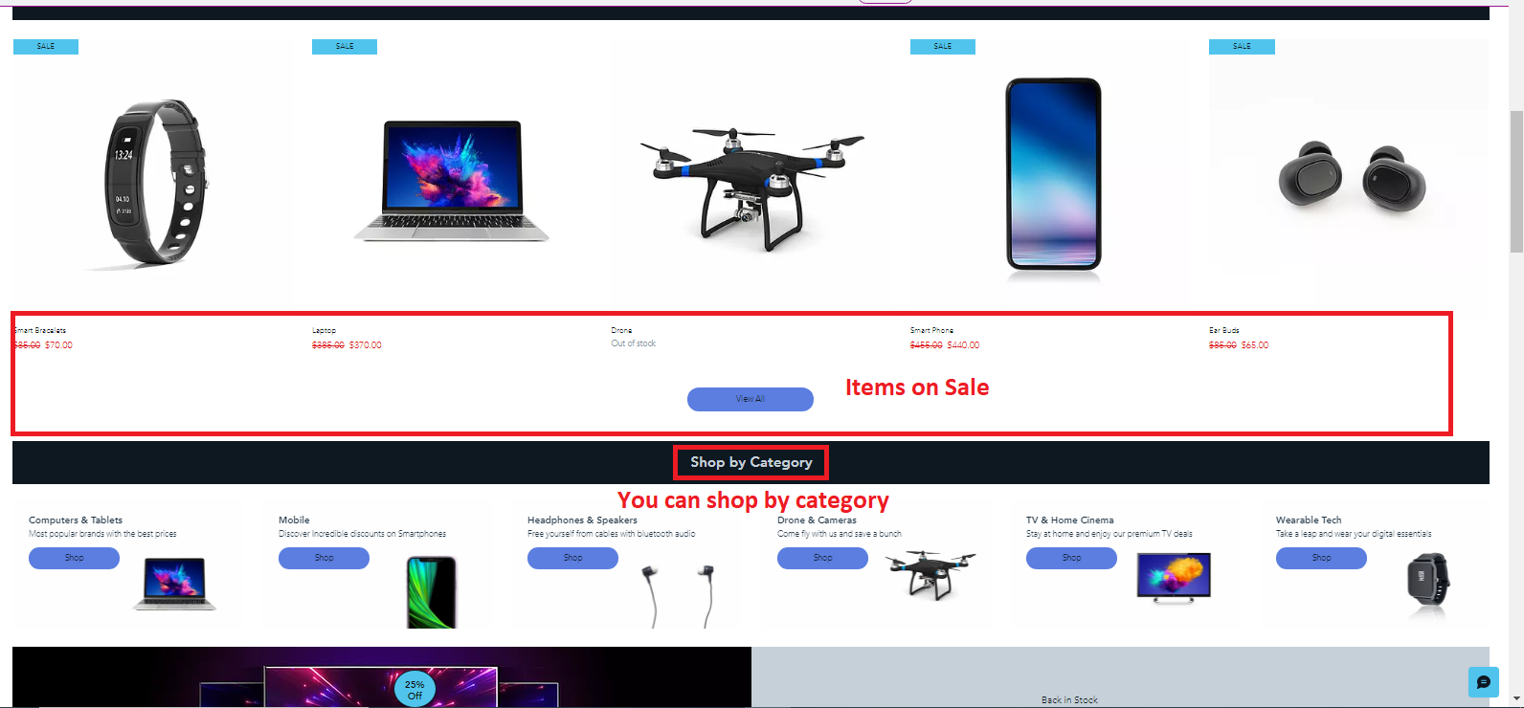

Figure : Products on sale

### 8.1.7 Products Filtering

Users can filter products by a drop-down menu with options that includes:

• Newest - Collection

• Price (Low to high),

• Price (High to low),

• Name A-Z,

• Name Z-A.

Through editing the dataset element in the backend, the filter can be customized. This can help the user to funnel what sort of items they may be searching for, faster.

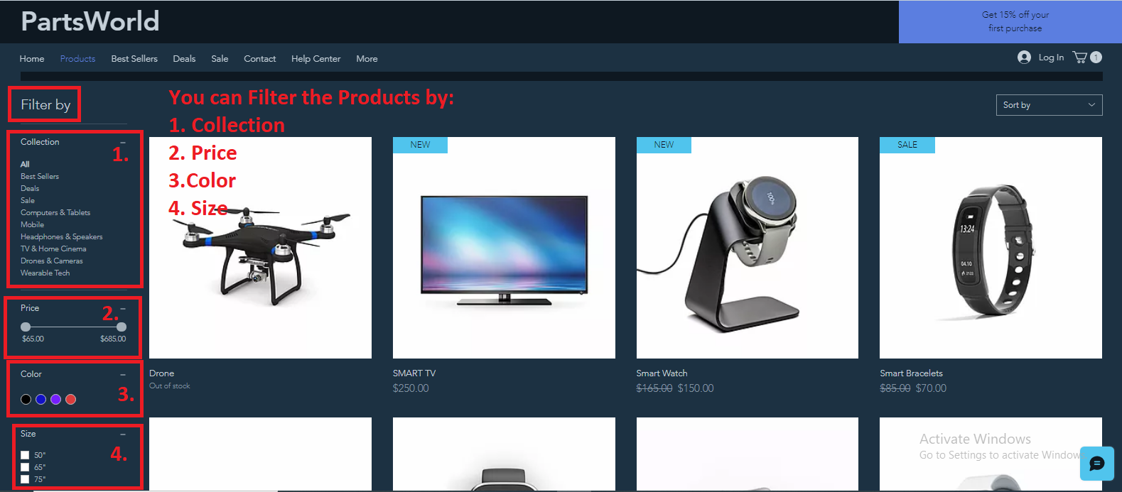

Figure : Filtering the products

### 8.1.8 Products Description

Product information is displayed along with images in plain text. Information initially includes placeholder product names as well as prices, which can be substituted for actual pricings and stock.

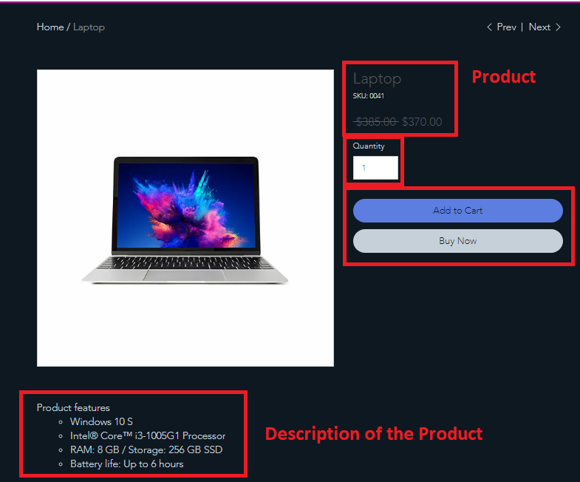

Figure 17: Example of Product Description

### 8.1.9 Cart Adding

Adding to the cart is done at any browsable store page on the website if the item is in-stock. When adding an item to your basket, you are required to enter the amount/quantity to add to your basket, once you have decided on the quantity of your product, you can either continue your shopping where it will send you back to browse other products, or you can proceed straight to the checkout where you can complete your order.

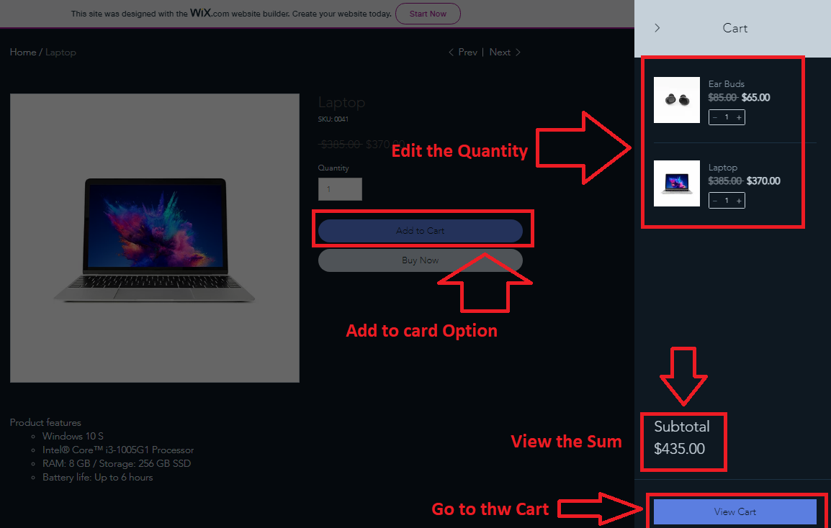

Figure 18: Adding Items to the Basket

### 8.1.10 Editing Basket

Editing the basket is done on the Cart summary page. A subtotal of all the selected items is visible in the basket and can be removed at this point before the user attempts to commit to any buying.

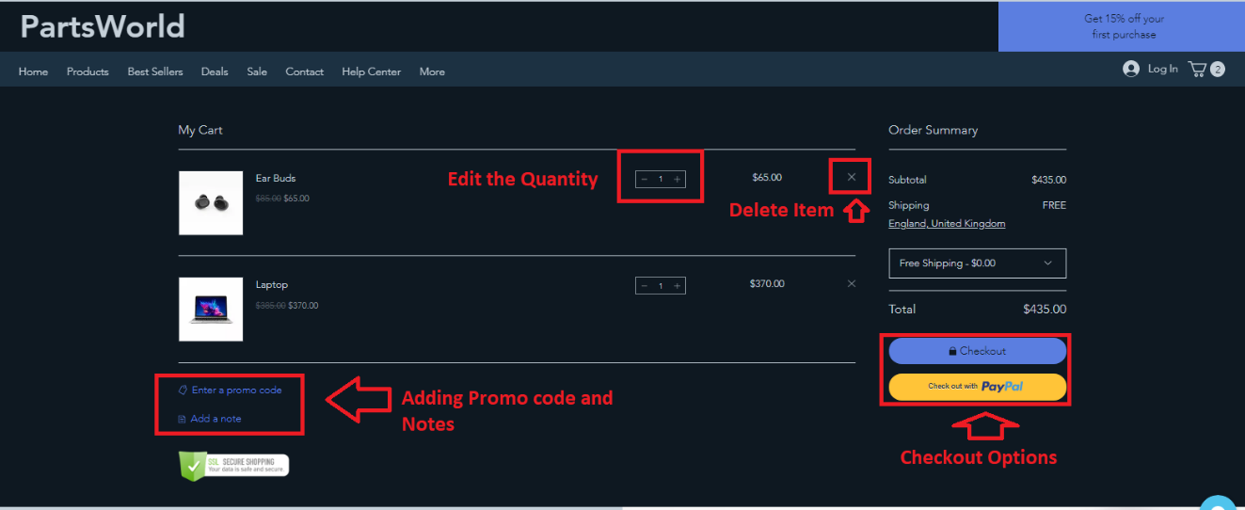

Figure 19: Basket page view

Deleting/removing a product from your basket is as simple as clicking the “X” can on the item you want to remove whilst within the basket.

### 8.1.11 Checkout Process

For payment, you can either select to pay entering your card details or by using PayPal. Once you selected which type of payment, this should take you to the payment page, we are unable to show this next stage as we are using WIX standard template, however we could include this premium feature (budget required) when the website will go life.

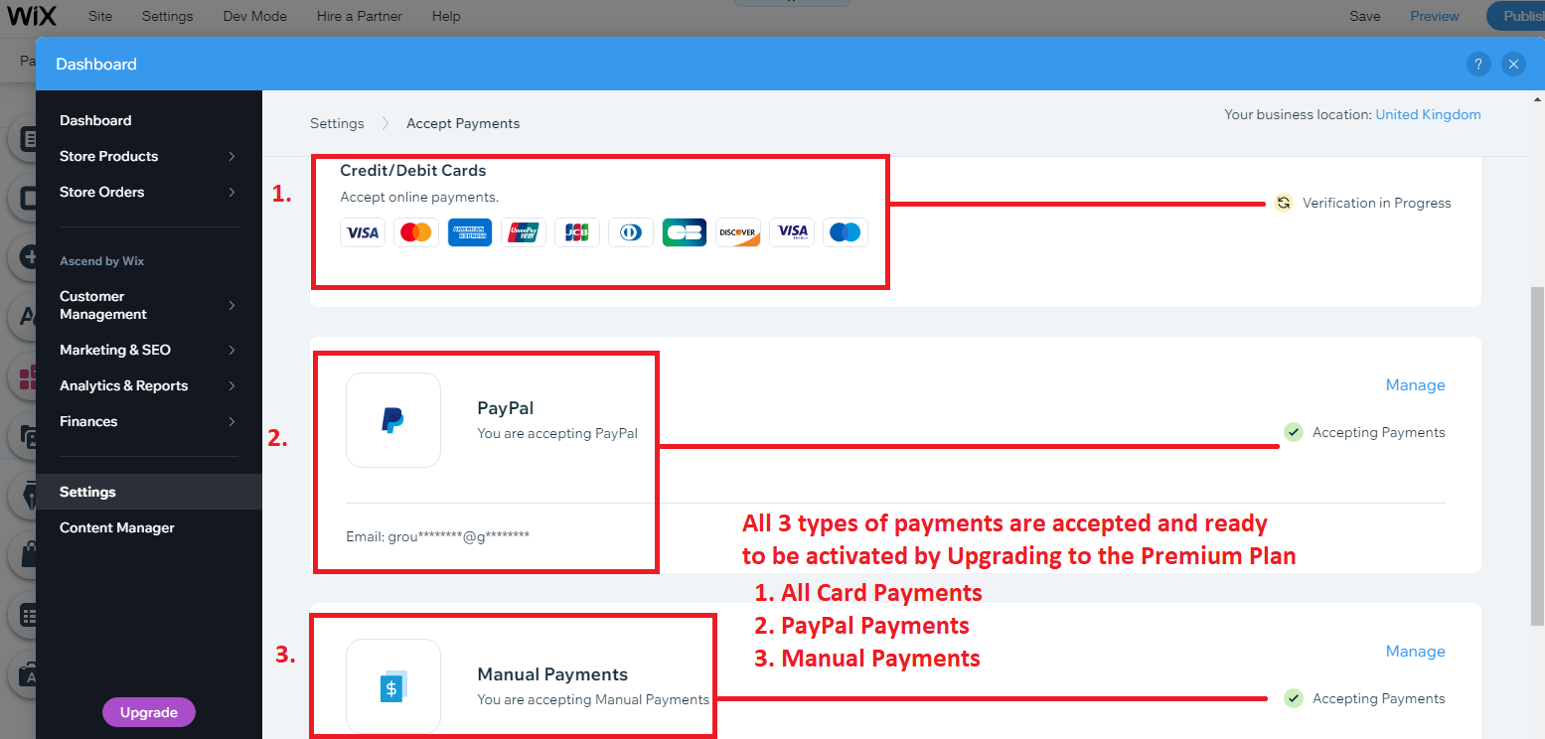

Figure 20: 3 Types of payment accepted at the Checkout

## Website Validation

## Testing (TM4)

Before we submit our website to the customer, we conducted a research using free survey application platform: [www.surveymonkey.co.uk](http://www.surveymonkey.co.uk). Questionnaire was passed to different customers to gather most valuable responses. Below are the actual results of the survey:

**1.This question is there to assess the whole process of how a user felt using the website from first visiting the website to buying a product.**

Figure 21: User satisfaction Questions

2.The 2nd question is asking the user to see how easy it was to find products in the store. This will test how good the user found the filter system on the website to be in helping them navigate towards items that fit the criteria they asked for.

Figure 22: Product filtering question

3.The 3rd question is testing to see if the user enjoys how the website looks if the colours look good together overall just making sure the website is aesthetically pleasing.

Figure 23: User Interface quality question

4.This is there to assess the overall user friendliness of the website that means how easy it was to look around at different parts of the website without being confused.

Figure 24: User friendliness of the website

5.This is testing to see how responsive we were in improving upon user feedback.

6.This helps us to see if users will come back and if not trying to improve the website, so they do.

Figure 25: Responsiveness and wish to buy again questions

7.This is seeing what the user thinks of the descriptions of items and how easily they let them compare.

8.This allows us to see if our support page is easily accessible for the user to give feedback.

Figure 26: Comparison and Contact questions

9.This was just to see if the user felt like it was easy to checkout and enter in their details.

Figure 27: Fillings about payment question

10.If there was anything the survey missed out on the customer could let us know any other things that would help improve the website

Figure 28: Concerns and improvements question

##### Testing Results

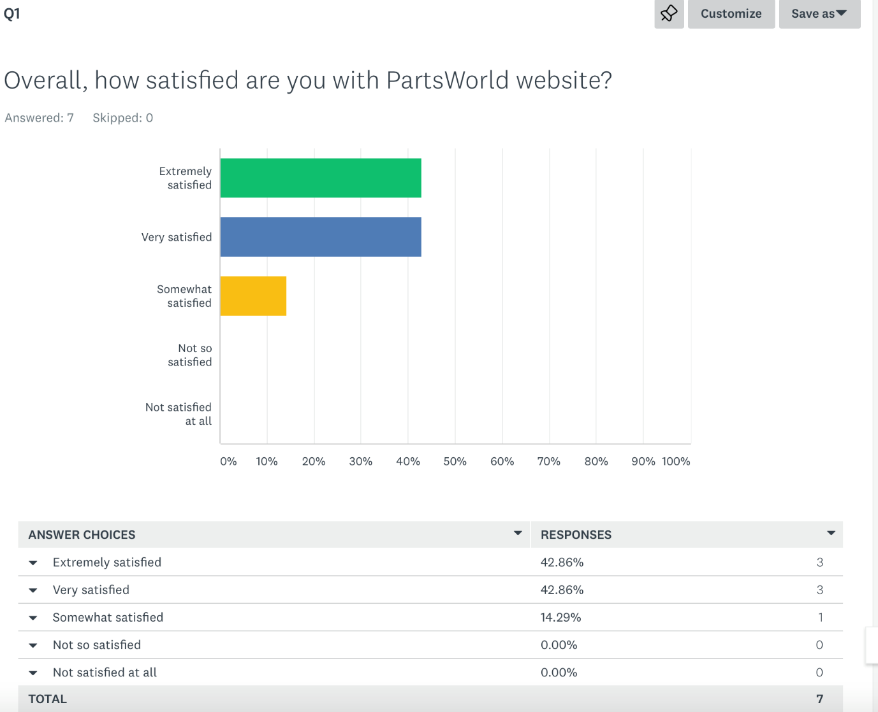

There were no unsatisfied people using the website overall with the most used response being extremely and very satisfied.

Customers seem to overwhelmingly feel like they can easily find different items meaning that the filter system and the categories are functioning as intended.

On this question 71.43% of the users who filled out the survey felt like the website had a High-Quality User interface in terms of design. This means that a lot of people felt like it was missing just a few things before becoming very high quality that could be improved in the future.

The user friendliness of the website could use improvement as 42.86% found it to be somewhat friendly.

There was a user who did not find us to be very responsive to their concerns so we should work on making sure people can contact us easily.

This was a positive result with 71.43% of the users being very likely to come back and buy our products using the website. There should however be an aim at identifying what made someone respond with not so likely to coming back to the website as that could prevent future customers from also being unlikely to come back.

Analysing this response 28.57% of users finding it very difficult to compare 2 items needs to be a big focus from us in improving our website. Since there is a big discrepancy between the results it could be that 1 demographic of users finds the website more confusing and we should be more accommodating with that with better features.

All respondents found it easy to contact support with website related issues.

100% of the responses felt they could pay stress free.

For this response they could respond with any concerns that were not addressed in the other questions. This will help us make better features.

### Analysis of the results

There were a few interesting results that came up from this quick survey we conducted. The website could for example become slightly more user friendly as it had a lot of people unsure about it with 42.86% selecting somewhat friendly when asked how user friendly the website is. In addition to that 28.57% of the people found that it was very difficult to compare 2 items. For the final question we asked if there were any other concerns and there were good criticisms showing that there were things to still improve on.

Future improvements due to the survey conducted: In the future we could improve the links in our website to be more descriptive and make it easier to understand how to navigate the website. To make it easier to compare 2 products we could add a section under the product page to compare it to another product side by side on the website with 2 different products next to each other easily allowing you to compare their specs and price. There was a mention of adding more payment processes which is something that can be added. A User mentioned wanting animation which sounds like the website could do more to make it satisfying to use and make you want to come back to use it so we could add animations to the home page for starters. There also needs to be a feature implementation of adding estimated stock arrival time as this will make the user want to come back to the website once they know a product will be back.

# Group Activities

## Group meetings

## Collaboration

Our team decided to collaborate through the Discord server and UWL Blackboard File Exchange platform, as well as GitHub repository. Every team member had access to the resources and was able to submit or review the files. Meetings were always going on the Group Work Discord channel, where everyone could express his opinion or suggestions, which helps us to respect each other’s opinion and follow the communication protocol (when one speaks others are listening and vice-versa). We tried to upload all the files to the GitHub server and UWL blackboard portal, to have easy access to them and never loose any of the documents.

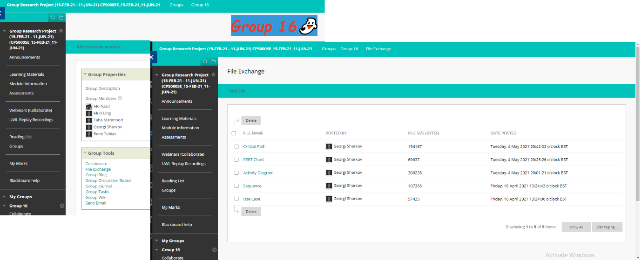

Figure 29: UWL Group 16 File exchange platform

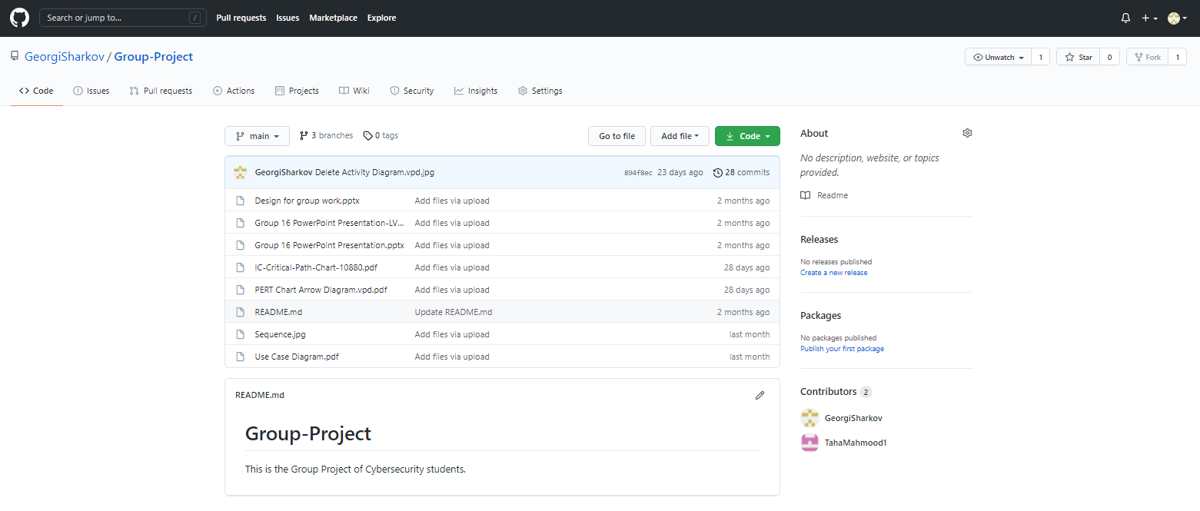

Figure 30: GitHub Group Project Repository for files exchange

Figure 31: Communication through Discord channel

## Personal reflection

## Conclusion

The main purpose of this project was to form a group of five members and to develop a web application together. We worked as a team through all the tasks. We gained a good habit during the presentation- every team member to participate and added his part. Even that everyone was having many other commitments such as other assignments to do, exams, work, family we managed to finish the project on time. We focused on core requirements of the project and tried to finish them first.

What we realised during the collaboration that every person was willing to help others. It was a great time working together and, in the meantime, getting to know each other better.

Even though our team was formed from the members of different groups (Cybersecurity, Computer Science etc.). that did not create any barriers in communication or to understand the task. We realised that some of the members were having less knowledge in the database systems, programming and this problem was covered from more competent in these areas members.

I, personally liked working in a group, chatting (especially during the pandemic time) resolving some issues together. We were risking not to finish the website design on time, but with the help of all members we completed that task much quicker by giving everyone something to adjust. Some team members were having other assignments to deal with that appeared as additional risk to us. We overcame that by splitting the bigger tasks to smaller parts and assigning them to more team members.

The biggest challenge to us was to show the payment process during the checkout, however we were not having any assigned resources (budget) to activate that feature (WIX offers that only to premium-paid-plan users). Moreover, we were able to create successfully a fully functional website.

Each team member gained some new skill during this project such as- Time Management, testing, database prototype, UML diagramming, cohesion, critical thinking.

# References

CPRIME, I., 2021. *WHAT IS AGILE?.* [Online]   
Available at: https://www.cprime.com/resources/what-is-agile-what-is-scrum/#:~:text=Agile%20software%20development%20refers%20to%20a%20group%20of%20software%20development,%2Dorganizing%20cross%2Dfunctional%20teams.  
[Accessed 05 05 2021].

Cunningham, W., 2001. *Manifesto for Agile Software Development.* [Online]   
Available at: http://agilemanifesto.org/  
[Accessed 04 05 2021].

FRIDMAN, A., 2016. *The Massive Downside of Agile Software Development.* [Online]   
Available at: https://www.inc.com/adam-fridman/the-massive-downside-of-agile-software-development.html  
[Accessed 05 05 2021].

Smith, K. A., 2007. *Teamwork and Project Managment.* Fourth ed. New York: McGraw-Hill Education.

The website can be accessed following the link below:

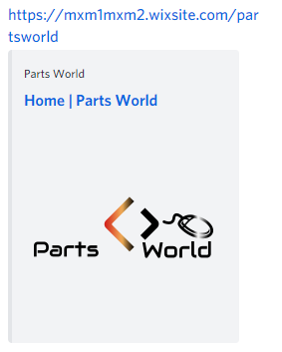

Database for the system can be accessed on the GitHub repository:

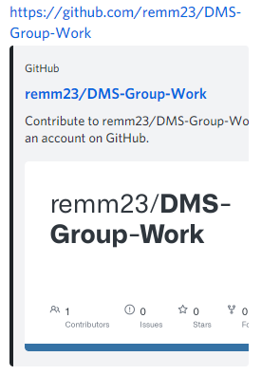

All UML Diagrams and